## CS5560 Knowledge Discovery and Management

Spark MapReduce Programing

PS2-B

6/12/2017

Class ID: 26

Name: suggala prudhvi sai

**Spark MapReduce Programming – Calculate everyone's common friends for Facebook**

Facebook has a list of friends (note that friends are a bi-directional thing on Facebook. If I'm your friend, you're mine). They also have lots of disk space and they serve hundreds of millions of requests everyday. They've decided to pre-compute calculations when they can to reduce the processing time of requests. One common processing request is the "You and Joe have 230 friends in common" feature. When you visit someone's profile, you see a list of friends that you have in common. We're going to use MapReduce so that we can calculate everyone's common friends once a day and store those results. Later on it's just a quick lookup. We've got lots of disk, it's cheap.

1. Draw a MapReduce diagram similar to the word count diagram below.

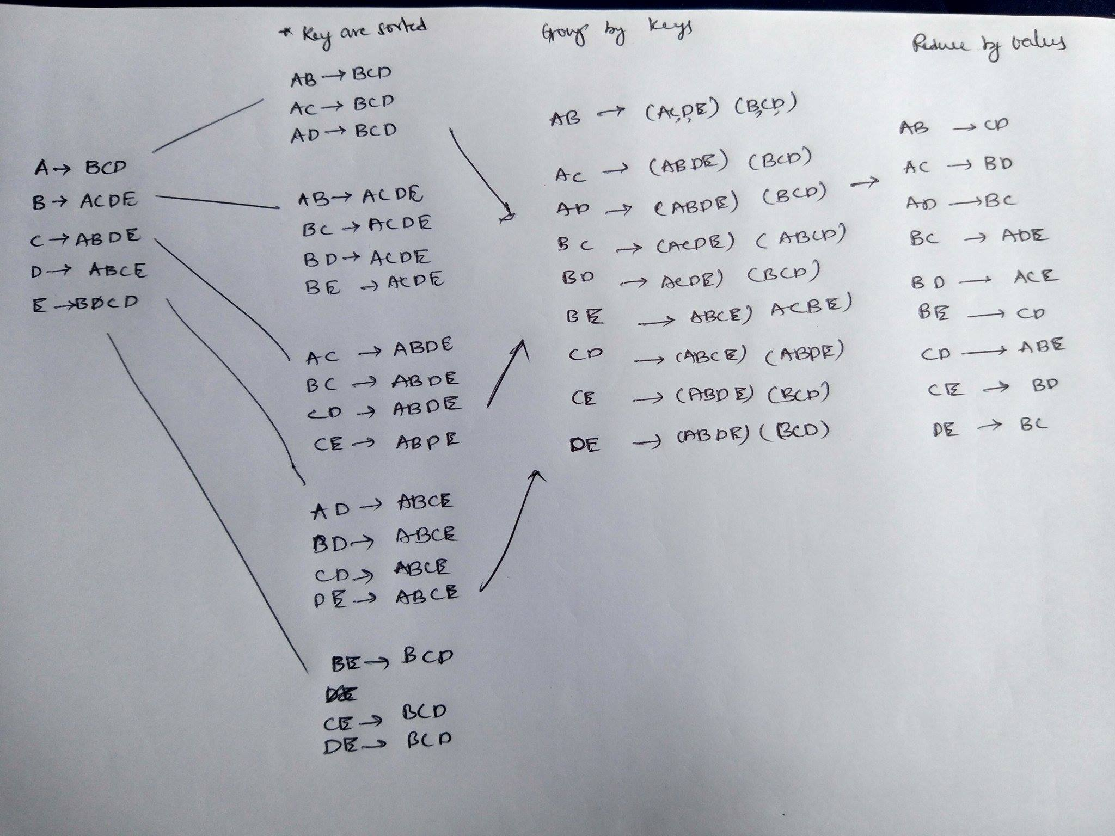

1. Sketch a MapReduce algorithm for the common Facebook friends (referring to the word count code below).

Map

Mapper programme used to map the keys to splits of values , then for each value of values new map is performed to form (key,eachof value )-> value

Reducer

Reduce by key is performed to remove duplicate copies

Reduce by values removes the non-mutual friends

1. Sketch Spark Scala implementation (referring to the word count code below).

Data – rdd contains data

Mod=data.map(key->value.split(“/”)

Mod1=mod.map(mod.value.count(foreach(key,value(i)->value))

New=mod.reducebykey()

Ans=new.reducebyvalue()